Under 12 Cougars (Greg Schwenke)

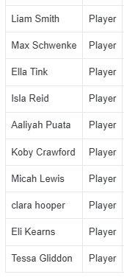
Hayleigh Reynolds
Johan Peter
Noah Fitzpatrick

MORE PLAYERS NEEDED!

Under 12 Panthers (Michael Irvine)

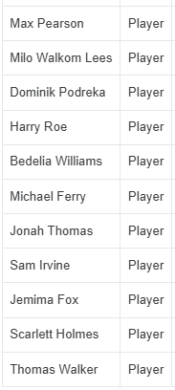
Jay Moss
Hugh Rosser
Roarke Menzies

