**Under 9 Panthers (Brendan Kent/Katrina Hutchinson)**

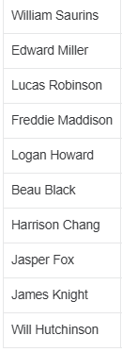

Archie Kent

**Under 9 Wildcats (COACH NEEDED)**

Stan Secheny

**Under 9 Lions (COACH NEEDED)**

