**Under 7 Panthers (Beau Barrett)**

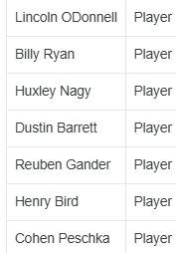

Drax Harvey

**Under 7 Pink Panthers (COACH NEEDED)**

Brooklyn Livingstone

**Under 7 Pumas (COACH NEEDED)**

**Under 7 Tigers (Glen Pearson/Co-Coach Needed)**

**Under 7 Wildcats (Candice Duesbury)**

James Corboy